Mr. Henderson’s Lesson Plans
Accessing Links for Students Work
Step1: Go to https://www.hcbe.net/
Step 2: Click on SSO Portal and login as they do at school
Step 3: You should now see a list of available apps. Click on the Clever App
Step 4: Here you have access to the apps on this page. If you click on Henderson’s page you will see several links that will be used to each week.
Content | Time | Instructional Resources or Directions
ELA/Reading | Spend about 20-30 minutes on Reading Independently daily | Choose one:  - Read a book of your choice that is on your level.  - Get on EPIC books and read.  (Our class code is kva6375)-Books are organized by lexile levels. Students should know their levels. If they don’t they can notify me and I will let them know what their lexile level is.  https://www.getepic.com/sign-in  - Scholastic News Grade 3-There are fun articles to read and printables that go along with the articles that cover 3rd grade common core standards. Go to Scholastic News Grade 3 and login with our class code: crowndog8448  https://digital.scholastic.com/resources/classpasscode/?app=sn3&state=%2F&role=classroom  - Readworks passages- Students actually read a passage and can answer multiple choice comprehension questions and constructed response questions to do on this site.  https://www.readworks.org/  - Istation Reading-Go to istation.com, Click on download, download the program, then when it asks for domain begin typing quail. You will then see quailrun.houstonco.ga, click on it, and hit the ok button. It will then take your child to the login screen. They will know what to do from there. Have them practice on the Reading portion of iStation.
 |  | BREAK-10 minutes
MATH | Spend about 30 minutes on Math daily | Choose one:  - Reflex Math-We are trying to reach 100% fact fluency in Addition/Subtraction and Multiplication/Division by the end of third grade. It is important that they know these facts so that they are successful in upcoming grades. Teacher name- chris.henderson Password- initials and a 2 digit number. (If they do not know it please message me and I can get it.)  - I Know it!-This is a site that gives quizzes over already learned skills. This is a great site to have students practice things we have learned. It gives them a grade after their quiz. Have them choose an assignment and work.  - Freckle-Get on and choose adapted practice and work on skills that are being introduced. This is working on things at your child’s level, so it may be things that are new and above grade level. https://www.freckle.com/ Click sign in-Enter Class Code- 368wfy  - Istation Math- Go to istation.com, Click on download, download the program, then when it asks for domain begin typing quail. You will then see quailrun.houstonco.ga, click on it, and hit the ok button. It will then take your child to the login screen. They will know what to do from there. Have them practice on the Math portion of iStation.  - Khan Academy-Go to Khan Academy.org, click on courses, find any third grade skill to review, or fourth grade skills to start practice if they want a challenge.
 |  | BREAK-10 minutes
WRITING | Spend about 30 minutes a daily | Choose one:  - Write a personal narrative or story about something that happened to you.  - Write an informational piece about a topic of your choice.  - Write an opinion essay about an opinion you have.  https://www.k12reader.com/subject/composition/prompts/opinion-persuasive-writing-prompts/  https://www.seeconference2013.net/the-top-15-best-persuasive-essay-topics-for-3rd-grade/  - Make up a fictional story that uses skills we have learned this year:  Writing in paragraphs, using quotations and dialogue, having a good introduction and conclusion, and using lots of details.  Other ideas for writing:  Write a comic strip, write your own fairytale, write a letter to a friend or family member, write your teacher a letter
 |  | BREAK-10 minutes
SCIENCE/  SOCIAL STUDIES | Spend about 30 minutes daily | - Mystery Science—my login is: chris.henderson@hcbe.net, password is: scienceonme  - Get Epic-Choose a book on EPIC that relates to a Science or Social Studies topic that we have studied this year:  (Science: the Environment, Pollution, Rocks, Minerals, Fossils, Types of Soil, etc,)  (Social Studies-Major Rivers in America, American Indians and where they lived, Regions in America, The Thirteen Colonies (we will cover when we return)  - Brain Pop and Brain Pop Jr.-Many Science and Social Studies topics are covered on here and printable worksheets are included on the site  Login-QRES, password-password1  I am planting a garden right now! It is so much fun and it would a great thing for your children to do while at home to learn about Science.
P.E. |  | CHOOSE ONE OF THE SPECIALS IDEAS DAILY  Don’t forget to exercise and take breaks learning!!  You can take breaks by going to GoNoodle, Ride a bike, doing Yoga, Dancing, or completing any of the activities from Coach Erpelding…  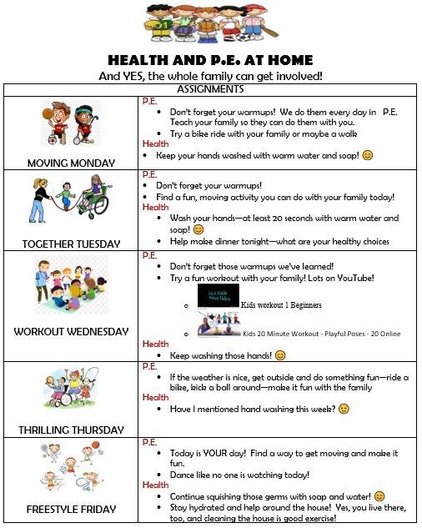
MUSIC |  | Mr. Layfield suggests this online digital music learning software for students to try:  http://www.QuaverMusic.com  Username: QuailRunCubs  Password: cub1
ART |  | There are many Youtube videos on how to draw this is only one suggestion:  https://www.youtube.com/channel/UC5XMF3Inoi8R9nSI8ChOsdQ  There are so many ideas for art projects on Pinterest too!
Need more ideas:
Learn to type-Typing.com from the Clever Site
Learn to Code-Code.org from the Clever Site
Learn a new language-Duolingo.com
Learn to play the piano-Hoffman Academy on Youtube
Learn to cook
Learn how to do chores

