Vasco Nunez de Balboa: Spanish Conquistador and Explorer
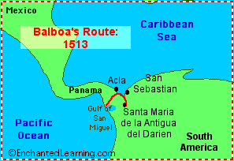
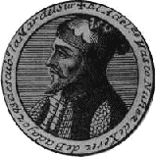
Vasco Nunez de Balboa (1475-1519) was a Spanish conquistador and explorer who was the first European to see the eastern part of the Pacific Ocean (in 1513), crossing the Isthmus of Panama.
In 1500, Balboa sailed with Rodrigo de Bastidas from Spain to Colombia, South America. They searched for treasures (pearls and gold) along the northern coast of South America and in the Gulf of Uraba (near San Sebastian). They were forced to abandon their leaky ship in Hispaniola. The penniless Balboa tried, unsuccessfully, to farm for a living.
In 1510, Balboa and his dog Leoncico stowed away on a boat going from Santo Domingo to San Sebastian. When they arrived at San Sebastian, they discovered that it had been burned to the ground. Balboa convinced the others to travel southwest with him to a spot he had seen on his earlier expedition. In 1511, Balboa founded a colony, the first European settlement in South America - the town of Santa Maria de la Antigua del Darien.
Balboa married the daughter of Careta, the local Indian chief. Soon after, in 1513, he sailed with hundreds of Spaniards and Indians across the Gulf of Uraba to the Darien Peninsula.
Balboa headed an overland expedition west through very dense rainforests. Along the way they fought many local Indians and destroyed one Indian village, killing hundreds of Indians. Balboa (accompanied by his dog) was the first European to see the eastern part of the Pacific Ocean (in September 1513, from a peak in Darién, Panama). Balboa and his men (including Francisco Pizarro) then traveled to the ocean and claimed it and all the land that touched it for Spain. They spent about a month conquering Natives along the Pacific coast and stealing their gold.
Balboa was charged with treason against Spain (although he was innocent and had been framed by a friend, Arias de Avila). Francisco Pizarro arrested Balboa. Balboa was found guilty and was publicly beheaded in Acla in January, 1519.

