Phases of the Moon Study Guide
- New Moon | 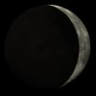  - Waxing Crescent Moon  "Waxing" means growing and refers to the size of the illuminated part of the moon that is increasing.
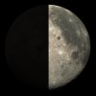  - First Quarter Moon | 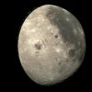  - Waxing Gibbous Moon
- Full Moon  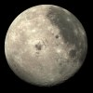  The full moon occurs when the Moon lies on the opposite side of Earth from the Sun. The moon as seen from the surface of the earth is fully illuminated by the sun at this time, presenting a "full" round disc to viewers on earth. | - Waning Gibbous Moon  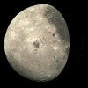  Waning means getting smaller.
- Last Quarter –Waning-Moon  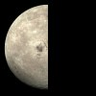 | 8, Waning Crescent Moon  (Then back to  1. New Moon)  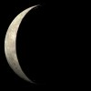
Waxing—When the illuminated part of the moon is growing. (Light part getting bigger.)
Waning –When the illuminated part of the moon is shrinking. (Light part getting smaller.)
Quarter Moon-Looks like ½ of the front side of the moon is light
Full Moon- Looks like the whole moon is light.
New Moon- Appears as if no part of the moon is light.
Crescent Moon- Looks a little like a sideways smile!

