John Cabot: Explorer
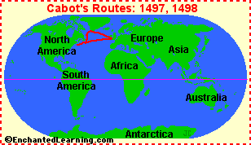
John Cabot (about 1450-1499) was an Italian-born English explorer and navigator. In Italy, he is known as Giovanni Caboto (which is his original name).
Cabot was born in Italy but moved to England in 1495. At the request of King Henry VII of England, Cabot sailed to Canada in 1497, commanding the small ship called "Matthew." Cabot landed near Labrador, Newfoundland, or Cape Breton Island (the exact spot is uncertain) on June 24, 1497. One of John Cabot's three sons, the explorer Sebastian Cabot, accompanied him on this trip. Cabot claimed the land for England.
Cabot explored the Canadian coastline and named many of its islands and capes. The mission's purpose was to search for a Northwest passage across North America to Asia (a seaway to Asia). Cabot was unsuccessful, although he thought that he had reached northeastern Asia.
Cabot undertook a second, larger expedition in 1498. On this trip, Cabot may have reached America, but that is uncertain. Cabot's expeditions were the first of Britain's claims to Canada.
John Cabot died in England in 1499.

