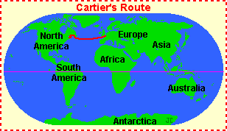
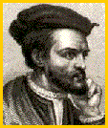
CARTIER, JACQUES
Jacques Cartier (1491-1557) was a French explorer who led three expeditions to Canada, in 1534, 1535, and 1541. He was looking for a route to the Pacific through North America (a Northwest Passage) but did not find one. Cartier paved the way for French exploration of North America.
Cartier sailed inland, going 1,000 miles up the St. Lawrence River. He also tried to start a settlement in Quebec (in 1541), but it was abandoned after a terribly cold winter. Cartier named Canada; "Kanata" means village or settlement in the Huron-Iroquois language. Cartier was given directions by Huron-Iroquois Indians for the route to "kanata," a village near what is now Quebec, but Cartier later named the entire region Canada.

