Henry Hudson: Explorer
Henry Hudson (1565-1611) was an English explorer and navigator who explored parts of the Arctic Ocean and northeastern North America. The Hudson River, Hudson Strait, and Hudson Bay are named for Hudson.
Little is known about Hudson's early life. Hudson was hired by the Muscovy Company in 1607, to find a waterway from Europe to Asia. Hudson made two trips (in 1607 and 1608), but failed to find a route to China. In 1607, he sailed to Spitzbergen (an island north of Scandinavia in the Arctic Ocean) and discovered Jan Mayen Island (a tiny island off eastern Greenland). In 1608, he sailed to Novaya Zemlya (an island north of Russia in the Arctic Ocean).
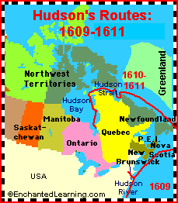
Hudson was then hired by the Dutch East India Company in 1609, to try to find the Northwest Passage farther south. On this trip in a ship called the Half Moon, Hudson sailed to Nova Scotia, and then sailed south. He found what is now called the Hudson River. Hudson is credited with discovering the location which is now New York City (although da Verrazzano had previously sailed by the area in 1524). Hudson sailed into New York's harbor on September 3, 1609 and noted what an excellent harbor it was. Hudson sailed up the river about 150 miles (240 km) and noted the abundance of rich land, but realized that this was not a waterway to India. His reports resulted in many Dutch settlements in the area.
A 1610-1611 trip through the Hudson Strait and into Hudson Bay ended in a mutiny. Hudson died in 1611 after his crew mutinied and left Hudson, his son, and seven crew members adrift in a small, open boat in Hudson Bay.

