**C:\Users\Shelley\AppData\Local\Microsoft\Windows\Temporary Internet Files\Content.IE5\2MOJ9L7F\MC900151183[1].wmfExpansion of a New Nation**

**Study Guide**

**The Westward Expansion- 1801-1861**

**Physical barriers that hindered and physical gateways that benefited territorial expansion**

**Mountains-** Mountains such as the Appalachians and the Western Rockies made westward expansion difficult. **Rivers** such as the Ohio River, Missouri River, Mississippi River, and the Columbia River made expansion easier.

**The Louisiana Purchase-1803** The port of New Orleans, Louisiana was very important to American farmers. When Thomas Jefferson became President it was controlled by France. Jefferson sent James Madison to France to offer them $10 million for New Orleans. Instead, France offered to sell not just the port of New Orleans, but the entire Louisiana Territory for $15 million. (It was less than 4 cents an acre! What a deal!) Jefferson purchased the Louisiana Territory in 1803 and the additional 828,000 square miles doubled the size of our country. (The French needed money because they were about to go to war against England.)

**Lewis and Clark Expedition-** Jefferson sent a group to explore the new territory. He appointed Meriwether Lewis to lead the group. Lewis asked his friend William Clark to help. Their jobs were to: gather information about the land, animals, and climates of the West; study the culture of the western Indians; and to explore the Missouri and Columbia Rivers. They were also hoping to find a water route to the Pacific Ocean. They were helped by an Indian woman namedSacagawea who guidedthem and acted as their interpreter. She was [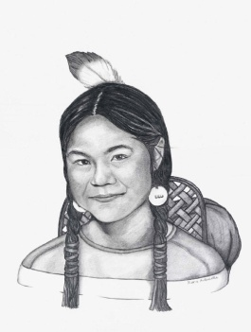](http://rds.yahoo.com/_ylt=A0PDoX9dTg5PjBcA7D6jzbkF;_ylu=X3oDMTBpcGszamw0BHNlYwNmcC1pbWcEc2xrA2ltZw--/SIG=124lem3ef/EXP=1326366429/**http:/www.portraitsofthesoul.com/sacagawea.html)able to communicate with other Native Americans and traded for much needed

s.strickland/4th

supplies, especially horses. The group of 30 people left St. Louis, Missouri in May 1804. After traveling about 8,000 miles they returned to St. Louis in 1806. They proved that it was possible to cross the continent through passes in the Rocky Mountains.

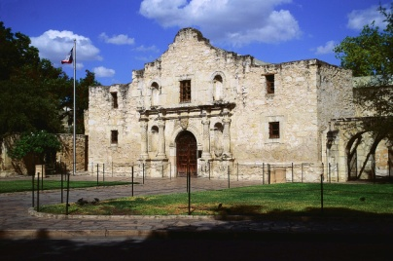**Texas- Independence and The Alamo-** in 1821 American settlers began arriving in Texas. Texas was a part of Mexico. The settlers wanted to break away from Mexico. In 1836, Mexico attacked the Alamo. (A fort that had once been a mission.) Most of the 200 Americans were killed defending the Alamo. The Americans eventually gained their independence from Mexico and then they voted to join the United States. In 1845, Congress voted to annex Texas.

**The Oregon Trail-** In 1824 an Indian showed a trapper a pass through the Rocky Mountains that was wide enough for a wagon. Thousands of people began traveling west through this pass, and the route became known as the Oregon Trail. The trail was 2,000 miles long. It began in Missouri, went across the Rocky Mountains, to present day Oregon.

**C:\Users\Shelley\AppData\Local\Microsoft\Windows\Temporary Internet Files\Content.IE5\IG8KGRL2\MC900229181[1].wmf**

**The California Gold Rush-** California became part of the United States in 1848. Gold was discovered there and thousands of people rushed there. More than 250,000 people poured into California during the California Gold Rush.

**C:\Users\Shelley\AppData\Local\Microsoft\Windows\Temporary Internet Files\Content.IE5\2MOJ9L7F\MC900329256[1].wmfInventions**

**Steamboat**

**1807-Robert Fulton**

Farmers used the rivers to transport their goods downstream. However, they had to walk or ride a horse home because they could not travel up stream. With the steamboat they were able to travel home by boat and that shortened their trip.

s.strickland/4th

**C:\Users\Shelley\AppData\Local\Microsoft\Windows\Temporary Internet Files\Content.IE5\05A7W7CP\MC900413498[1].wmfSteam Locomotive**

Steam engines had a huge impact on travel because they were fast. They could easily go up and down hills. A 30 hours trip by steamboat would only take about 10 hours by steam engine. By 1850, there were 9,000 miles of railroad track in the United States. They made it much easier to transport goods and materials all over the country.

**C:\Users\Shelley\AppData\Local\Microsoft\Windows\Temporary Internet Files\Content.IE5\TPN57OE0\MC900234127[1].wmfTelegraph**

**1844-Sam Morse**

Sam Morse invented a code system where dots and dashes represented letters. In 1844, he sent the first message over the telegraph wires. Within 17 years it would stretch from coast to coast. News was able to travel much faster.

**Native Americans and the Westward Expansion**

As the more and more settlers and pioneers poured into the western lands, the way of life of Native Americans was changed forever. Sometimes confrontations led to conflict. The struggle of American Indians to keep their homes continued for decades.

**The Abolitionist and Suffrage Movement**

**The Abolitionist Movement-** A movement to bring an end to slavery. Abolitionists included people in the North and South. The Underground Railroad was founded to help runaway slaves escape to freedom. It was a series of escape routes and hiding places to bring slaves out of the south. The people who helped lead the slaves were called conductors.

**Suffrage Movement**- A movement to bring rights to women including the right to vote, own property, and earn money.

**[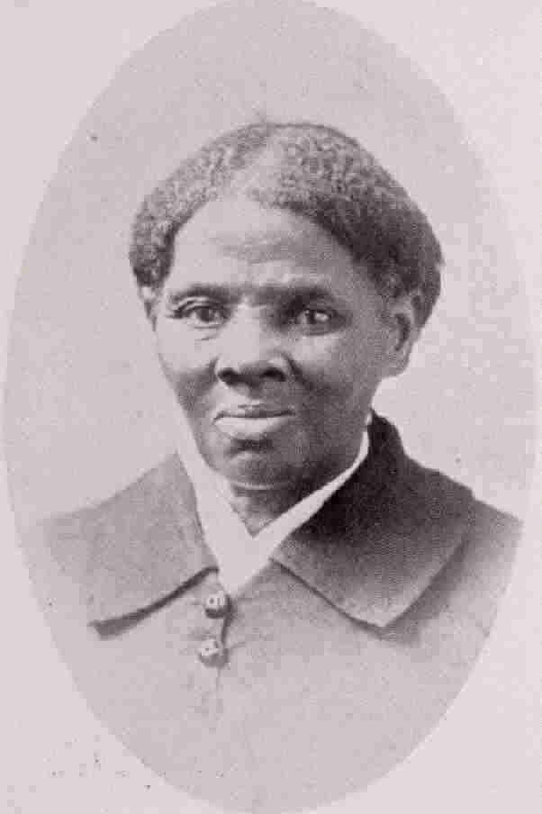](http://rds.yahoo.com/_ylt=A0PDoS5KTw5P2CkAFGyjzbkF;_ylu=X3oDMTBpcGszamw0BHNlYwNmcC1pbWcEc2xrA2ltZw--/SIG=12jbe3das/EXP=1326366666/**http:/www.herstorynetwork.com/herstory-lessons/harriet-tubman/)Harriet Tubman-** The most famous of the Underground Railroad conductors was Harriet Tubman. She escaped slavery from Maryland. Then she returned 19 times to help lead 300 others to freedom. s.strickland/4th

**[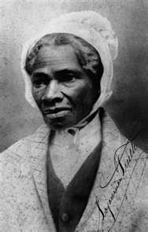](http://images.search.yahoo.com/images/view;_ylt=A0PDoTGjTw5P9mIAlEWJzbkF;_ylu=X3oDMTBlMTQ4cGxyBHNlYwNzcgRzbGsDaW1n?back=http://images.search.yahoo.com/search/images?p=sojourner+truth&n=30&ei=utf-8&tab=organic&ri=5&w=286&h=448&imgurl=uncfsu.files.wordpress.com/2010/12/sojourner-truth.png&rurl=http://feministstudentsunited.org/&size=141.8+KB&name=Sojourner+Truth+(1797%E2%80%931883)&p=sojourner+truth&oid=231210cb3ed25e7fc18f772e40c564bd&fr2=&fr=&tt=Sojourner+Truth+(1797%E2%80%931883)&b=0&ni=40&no=5&tab=organic&ts=&sigr=112v0b77r&sigb=12tphngco&sigi=11m918c5m&.crumb=fgyRhsHsNYI)Sojourner Truth**

[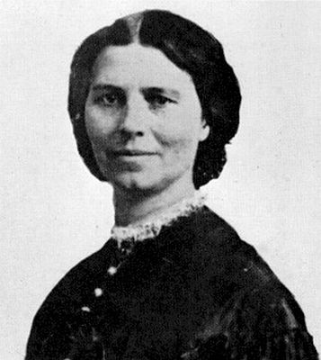](http://rds.yahoo.com/_ylt=A0PDoS56Tw5PhnEAfpSjzbkF;_ylu=X3oDMTBpcGszamw0BHNlYwNmcC1pbWcEc2xrA2ltZw--/SIG=12rao0uuk/EXP=1326366714/**http:/www.blackpast.org/?q=1860-elizabeth-cady-stanton-slaves-appeal)She was born into slavery. She traveled around the United States speaking against slavery and for women’s rights. Her most famous speech in favor of women’s rights is titled, “Ain’t I A Women?”

**Elizabeth Cady Stanton**

She was a leader of the suffrage movement for over 50 years. She did not live to see it, but her work helped women gain the right to vote in 1920.

**Important Physical and Man-made features in the United States**

**New York City, New York**

Founded in 1624 as a trading post by Dutch colonists. The city came under [English](http://en.wikipedia.org/wiki/Kingdom_of_England) control in 1664 and was renamed *New York* the [Duke of York](http://en.wikipedia.org/wiki/James_II_of_England). It served as the [capital of the United States](http://en.wikipedia.org/wiki/List_of_capitals_in_the_United_States#Former_national_capitals) from 1785 until 1790. It has been the country's largest city since 1790.

**Boston, Massachusetts**

Capital city of Massachusetts and one of America’s oldest cities. Founded by the Puritans in 1630, it was home to many historical events including the Boston Tea Party and the Boston Massacre.

**Philadelphia, Pennsylvania**

Located on the Delaware river, it was America’s first large city in America. Home of the Continental Congresses, the Constitutional Convention, and Benjamin Franklin. It served as the [capital of the United States](http://en.wikipedia.org/wiki/List_of_capitals_in_the_United_States#Former_national_capitals) from 1790 until 1800.

**Erie Canal**

In 1817 the New York legislature decided to build a canal between Lake Erie and Troy, New York on the Hudson River. It was named the Erie Canal. It was finished in 1825 and was 363 miles long. It provided a much cheaper and faster way to ship goods.

s.strickland/4th